**Safety F1rst Community Training Centre** Summer 2018 Newsletter - issue number 4

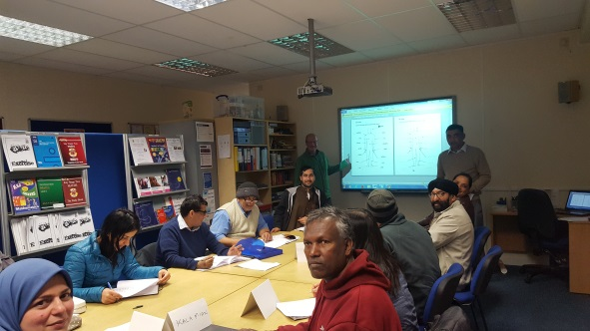

English for Speakers of Other Languages [ ESOL ]

Welcome to the Safety First Community Training Centre Newsletter.

As we wind down for our Summer break, we would like to thank all of our Centre users , volunteers, Trustees and staff for their hard work during this year.

There has been challenges and many successes too!

This year we have worked with over 400 adults at the Centre and at other local venues throughout Bradford.

Courses at the Safety First Community Training Centre have included :

ESOL - English for Speakers of Other languages.

Functional Skills; English, Maths and ICT

Job Search / Employment Skills/ Confidence

Reading and Writing for Beginners

Whats happening during the Summer ? **Chartered Institute of Environment Health**

Food Safety course Level 2 [ Fri. 3rd 10th 17th Aug. ]

The Certificate in Food Safety is designed for anyone working in a food business. Upon completion of this course, you will be able to prepare and cook food that is safe for consumption.

**Life in the UK course**

Safety First provide Life in the UK courses to enable learners to access affordable teaching and learning, that will assist them with the Life in the UK test

•Speaking & Listening element via ESOL Classes using Life in the UK manual

•Life in the UK multiple choice practice tests via computer sessions

Every Wednesday Job Search Workshop includes help with I.T. programmes 10 – 2pm

Centre users taking a break in the Café area

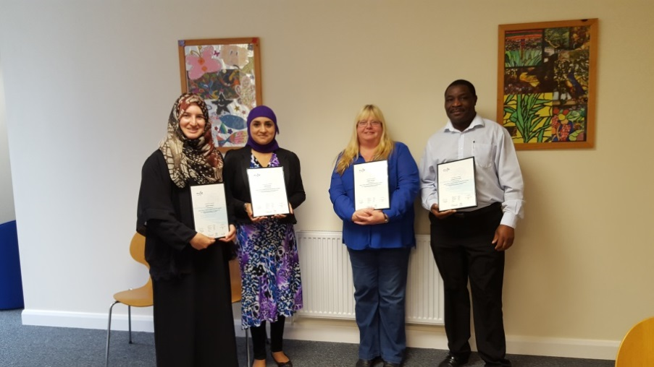

Safety First Volunteers with awards

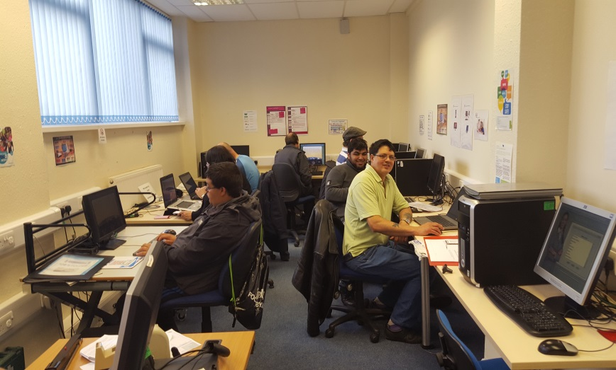

**Successes @ Safety First Community Centre** Our Centre user group has reported that we have had our most successful year since we became registered as a charity ten years ago. One of our most needed courses this last year has been the help with reading and writing for adults. The need was identified by the user group , staff and volunteers. We have worked with 32 adults on the project who had difficulty with reading and writing. We wrote to the **Foyle Foundation** who were able to support us with this with a grant of 2,500. One of the massive outcomes that came from this was that one of the learners on this course who could not read and write and was unemployed has now been able to get a full time job with Morrisons Supermarket. **Helping the Police** In May, Safety First were successful in receiving a grant of 4,102.00 from the West Yorkshire Crime Commissioners Office to work with diverse groups of adults who had been victims of modern slavery. Courses have now begun to help men and women to develop English language skills , build confidence and help make contact with other support agencies. **E-Street Café** Sovereign Healthcare has donated 5,000. To help us with our Fairshare café @ E-Street. This will allow us to buy a new fridge and cooker, update the kitchen and run CIEH Food Safety courses. **Good Things Foundation** we are proud to be working with the Good Things Foundation delivering much needed ICT and language support to those who are furthest from the labour market. **We would like to say thank you to all of our supporters , you help us to make a big difference to so many people.**

Computer classes and Employment support at the Centre

Who’s who at Safety First



Mrs Nazmin Din – Charity Trustee **Trustee Role** ; Vice Chair

**Specialist area**: Education and Holistic Health

Nazmin has over twenty five years in the Education sector and is known throughout the Bradford Community for her professionalism and ‘can do’ attitude. In addition to her community and pastoral expertise she has a great understanding of health and wellbeing and is a Holistic Health practitioner.

Nazmin brings an important Community, Education and Health element to the charity .

**

*This issues star volunteer at Safety First has been with the charity since its formation in 2008*

Who’s Who

=